Background

Job Corps Program Instruction Notice 19-17 directed centers to transition to virtual operations with students participating in various aspects of the program virtually. Job Corps has invested in information technology (IT) to support distance learning for off campus students through purchases of chrome books, software, and hot spots to support a national distance learning program. to support Job Corps’ students that lack access to technology. It is anticipated that 20,000 chrome books and hotspots will be delivered to Job Corps Centers in quantities informed by DOL student surveys. Equipment is scheduled to be delivered to centers during the second half of July 2020.

Accountability

Property funded, leased, or owned by U.S. Department of Labor (DOL)/Job Corps and furnished to Job Corps contractors is contractor-held government-furnished property. Government-furnished property (GFP) is administered by the Job Corps National Office, with assistance from the Job Corps Regional Offices, and is managed on location by Job Corps contractors.

The PRH and Job Corps contracts require operators to develop and maintain an inventory system to account for all property in accordance with procedures in Employment Training Administration (ETA) 359, ETA Property Management Handbook. – PRH Appendix 505.

Systems

The Job Corps community has recommended that DOL establish an interface between EPMS and CIS to account for IT equipment loaned to students. This interface is intended to transfer liability and accountability of the loaned equipment to the student, who would then become the custodian of the property. If any equipment loaned to students becomes missing, damaged or destroyed while in the possession of the student the center operator could employ existing Job Corps policies to recover the cost of the missing, damaged or destroyed equipment through restitution as outlined in PRH 6.3R4d1.

Options to record student issues were provided by the Job Corps Community. The Job Corps Data Center has drafted similar business rules and reports, which provide for an interface between EMPS and CIS and include output reports to provide for student loaner issue tracking, as illustrated below:

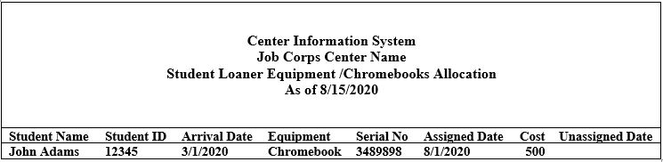

Hold Harmless

Center operators are seeking policy language to be held harmless of equipment issued to students when such equipment is in the student’s sole position and is in support of virtual learning, and cannot be monitored, managed, or inventoried by the operator. Such relief of accountability is requested as part of the contract modification and/or PRH change notice, which addresses student liability, restitution, recovery of funds, and unrecovered funds. Insurance should also be an option for operators to cover student losses.

Job Corps Center
Student IT Distribution Flow Chart

- Centers Receive IT equipment from manufacturer and validate inventory in EPMS .
- Center Director Certifies EPMS. Corrections will be reported to JCDC. All equipment will be tagged “Property of the U.S. Government.”
- Centers Distribute IT User Agreements to student.

- Center records SN of equipment on signed user agreement for each student.
- Centers ship (return receipt requested and insured) IT equipment to student with a copy of the annotated agreement and hand receipt.
- Signed Agreements are returned and used to determine allocations.

- Centers reconcile reports in EPMS and CIS. EMPS “Student Loaner” Location. Quarterly/Annual inventory and transitions will include all EPMS equipment.
- Center enters distribution in CIS (newly created module) to record SN, date assigned, and cost. (May be accomplished through EPMS).
- Annotated agreement and hand receipt is scanned to the student’s e-folder (finance/other) unless DOL creates an “IT Issue” tab.

- Reissue: Centers shall clean and service returned equipment and prepare for reassignment to another student, repeating previous steps starting at #4.
- Student Separation: Upon separation, student loaned equipment will be recovered, inspected, and students will be relieved of accountability in EPMS/CIS. Property returns to the possession of the operator

- Relief of Accountability: Identify and report missing, damaged, or destroyed government property using the Report of Survey/Inventory Adjustment Report (Form ETA 396), and forward to the Regional Office.
- Disposition/Restitution: Centers shall initiate restitution of lost/damaged issues per 6.3R4d1 and record same in CIS (fine/restitution). Payment will be credited to expense (capital equipment) for repurchase or DOL recovery.

- Lost/Damage: Center shall initiate SIR (Theft or Damage to Property), Infraction, as applicable (e.g. theft, vandalism, etc.), and investigation.

- Repairs: Students will report repair needs to property. A work order will be initiated to affect repair.

