**Remote Staff Training Guide**

**During Job Corps’ Spring Break & Distance Learning Status**

**Objective:** To provide Job Corps staff meaningful and relevant training in a remote/virtual environment. Typical Job Corps staff training is conducted in-person and on-site through a mixture of Center management teams and Corporate area experts.

Job Corps has made it’s Learning Management System (LMS) available remotely to staff through their Citrix accounts, which can be accessed with a soft token. Information regarding LMS courses is provided at the end of this document.

Due to the extended spring break and the limited ability to train on-site there is need to coordinate and provide additional, diverse training opportunities to accommodate staff working remotely. Remote learners can best access training via a web-based delivery approach. This allows staff to use personal phones, tablets and other devices to access training materials from remote locations.

This guide presents an option for remote staff training that can supplement the LMS. In this approach, staff are presented with a list of trainings upon login to the remote training site. The training list is for the current week, based on their position. Access is also available to prior week assignments and supervisors can download a pre-configured training log to record staff training completions for submittal to HR for documentation and tracking purposes.

***Note:*** *This approach to deliver position-specific trainings through a website could also be accomplished through individual, weekly emails to staff.*

**Training Platform Design:**

* Each training/course consists of a Title, Description, URL Link(s), and Note section. An example of two trainings are attached, exactly as they appear to the staff-trainee online. As a best practice:
  + All trainings have a quiz or assignment the staff must complete and provide to their supervisor upon completion. These questions may simply verify the staff member watched/read the content, or open-ended questions asking for the staff to apply what was learned.
* All trainings must have one or more links (URLs). The suggested approach involves 3 links:
  + First, provide a link to a one-page introduction document describing the course, learning objectives and expected completion time requirements. Standardize this introduction page layout to improve user experience between trainings.
  + Second, provide a link to the actual training content. Preferably, a balanced training topic will include multiple media types: e.g. read an article, study a PowerPoint and watch a video.
  + Lastly, provide a link to the quiz or assignment. Fillable PDF documents are recommended, which allow most users to directly leave their responses in a pre-formatted document without the need to have Microsoft Office installed. However, for those who are unable to use fillable PDFs, we also provide the quiz or assignment in the “Notes” section for direct Copy-and-Paste into email. Preferably, a mixture of quiz items and assignments should be included. Do not exclusively use multiple choice, closed-ended questions, or fact-checking questions. Include open-ended questions, ask the staff to apply what they have learned, or give an assignment to create or do something.
* The “Notes” section should provide any clarification needed to ensure all staff can complete the assignment. Sometimes a single sentence may suffice, e.g.: “Read the article in Link #1, answer the questions in Link #2, and provide responses to your supervisor.” In other cases, the Notes section may provide guidance such as: “Follow Link #2 and complete the first 3 modules; modules 4 through 6 are not required.”

**Training Goal:**

* To allow staff the opportunity to fulfill non-training work responsibilities, a recommended target is to provide Managerial staff with 10 hours, and Non-Managerial staff with 20 hours of training material per week. This target; however, can be adjusted by position or by individual to allow the supervisor to take into consideration other responsibilities staff may have to fulfill while working remotely.

**Resources Needed:**

* The labor required to create a custom-tailored weekly curriculum cannot be understated. As such, this approach relies heavily on Corporate area experts coordinating with, and receiving training recommendations from, Center staff. These recommendations are continually solicited and reviewed in advance, creating a menu of training materials to be delivered in future weeks.
* It is recommended that non-management and management Center staff from multiple departments and locations are selected to participate in a “beta test” prior to the full deployment of the training for future weeks. Through this process invaluable feedback is received and corresponding corrections can be made prior to a “live” release of the training. This also provide the opportunity to gain honest feedback after the week is over to continually improve future trainings.

**Training Examples:**

* The attached excel workbook lists four weeks of training that has been made available to a variety of Center staff. This four-week list includes the training subject and the URLs. The following page shows an example of two of the training courses available in the workbook.

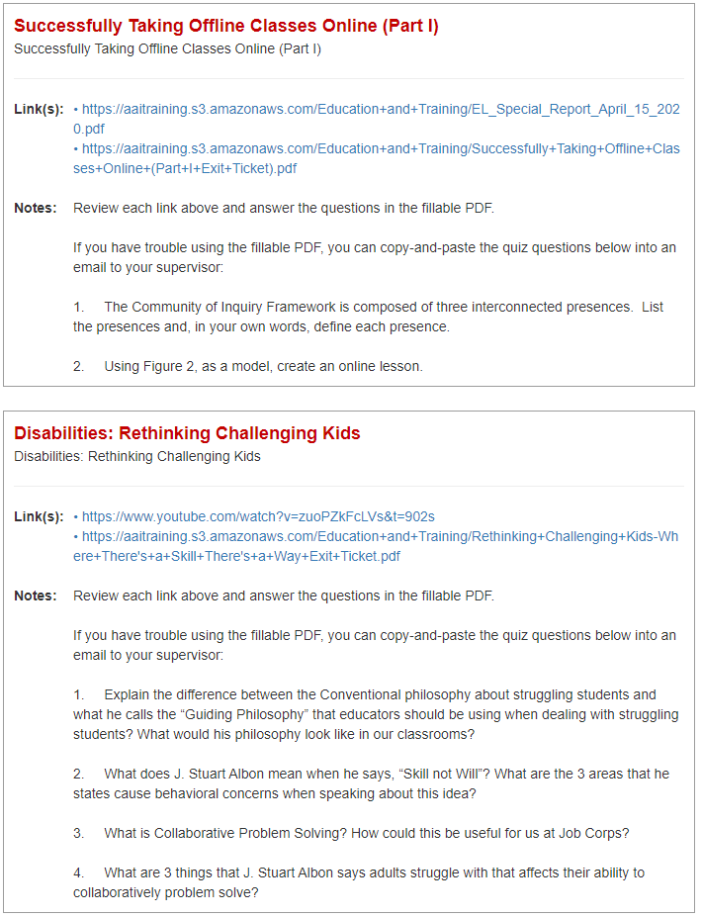

**Job Corps’ Learning Management System (LMS):**

Job Corps’ LMS can be accessed through staff’s Citrix account. Citrix can be accessed remotely through the use of a soft token. The following is a listing of the course subjects available in the LMS.

