Student Issued Chrome Book

CIS Process - Hybrid EPMS Inventory:

The concept would be to track the chrome book distribution through CIS. A data field would need to be created (i.e., Technology Allotment) by the Data Center that would include the date, description, serial number and dollar value (similar to clothing allotment module in CIS – see below)

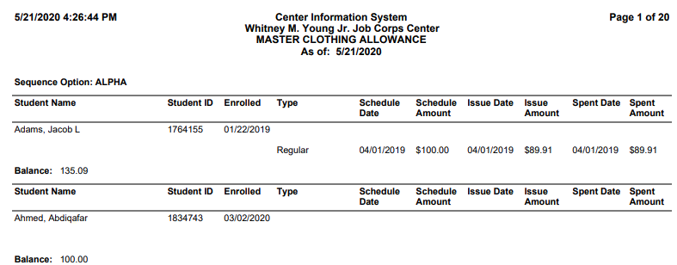

Advantages:
- Ease of reporting to determine which students currently have been assigned technology
  - Anyone (national/regional) can run a CIS report to determine the level of distribution of the allotment
- Ease the logistics task to track individually assigned chrome books vs EPMS requirements
  - No requirement to conduct a quarterly/annual property audit
  - No requirement to submit the Form 3-96 and police reporting that is required for missing/misplaced/mishandled chrome books
- Responsibility shifts to the students to care for their property/equipment
- Reimbursement for misused/lost/stolen chrome books can be processed via pay deductions through SPAMIS if applicable
- Provides DOL with property accountability
  - Note: Property is accounted for and is the responsibility of the center throughout the process until the chrome book is received and acknowledged by the student.
    - Once the center receives the signed form – the responsibility transfers to the student

Property Officer Responsibilities:
- Chrome books would be distributed to the center via EPMS. The center property officer would accept the inbound transfer in EPMS
- Once received and documented in EPMS, an SF-120 would be issued to remove the chrome books from EPMS. (SF-120 Form is included)
  - The Region would approve the SF-120.
- The inventory would then be tracked by the property office in an excel “Chrome Book” titled environment. The sheet would contain 2 tabs – “Undistributed” and “Distributed”
  - As Chrome books are issued to students – the master sheet would be updated. The chrome book information (student name, serial number, etc.) would be moved from the “Undistributed” tab to the “Distribution” tab

Exception:
- A waiver would be required to track the chrome books as non-property once they are distributed to the students. Until distributed, the chrome books would remain as GFE under the sub-tracking system.
  - The property officer would be the assigned custodian until the chrome books are issued to the students

Student Records Responsibility:
- A list of the Chrome books (by serial number) from EPMS would be provided to the Student Records Manager.
  - The manager would enter the serial number and other pertinent information into CIS for each student receiving the chrome book (recommend the creation of the field under Finance – Technology Allotment)
    - A copy of the Technology allotment report would be provided to the Property Officer for final disposition/reporting
      - The Property Officer would the move the applicable Chrome book from the “Undistributed” to the “Distribution” tab.

Student Responsibility:
- A form (CIS Report) listing the date, serial number, amount, and responsibilities will be sent to the student for signature.
  - A form/statement of responsibilities will be codified for uniformity throughout Job Corps
  - The signed form will be uploaded into CIS as a pdf file (recommend adding a Technology Allotment folder) for accountability purposes in the eFile system
  - Output reports will provide a summary of allocation and inventory:

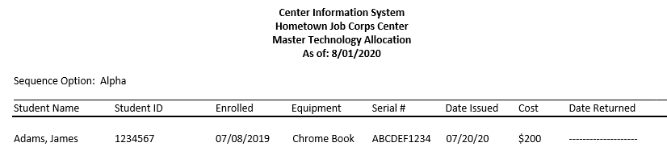

Replacement Chromebook:
- Student will ship the chrome book to the center.
  - The property office will log the serial number and handle according to CPMP repair action procedures
    - Data Center correspondence will be kept in the file for all repair actions
  - A replacement chrome book will be shipped to the student should there be available inventory on the center
    - Procedures above should be followed when issuing a new chrome book

Student Return to the Center:
- Continue to issue chrome books to new students during CPP using process above

Reconciliation
- Centers will reconcile the Master Technology Allocation Report against the GFE sub-tracking system.

